**Market Analysis in Banking Domain**

1. *Starting SPARK SHELL*

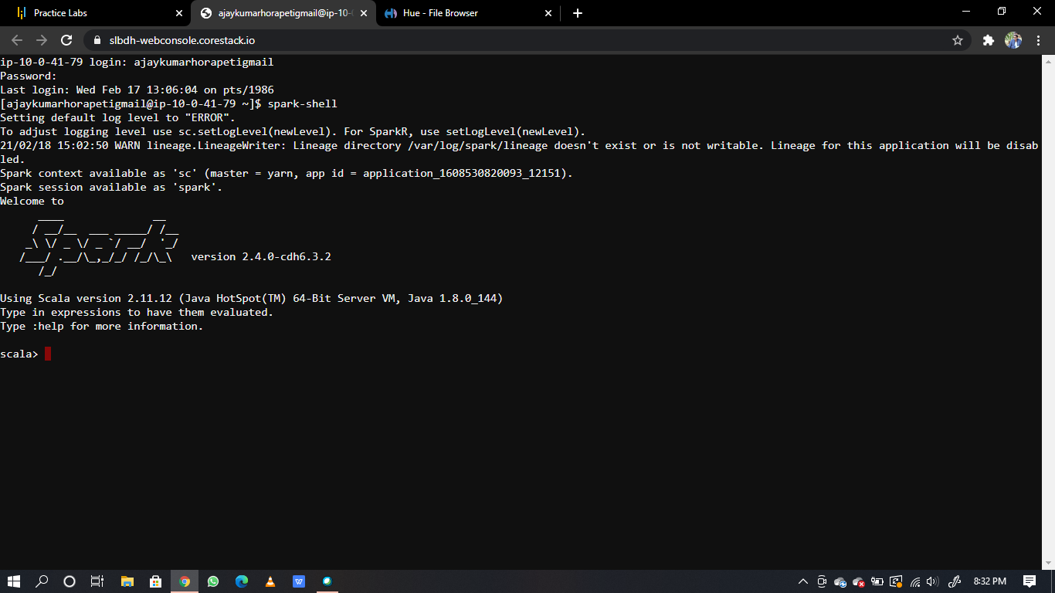

1. Load data and create a Spark data frame.

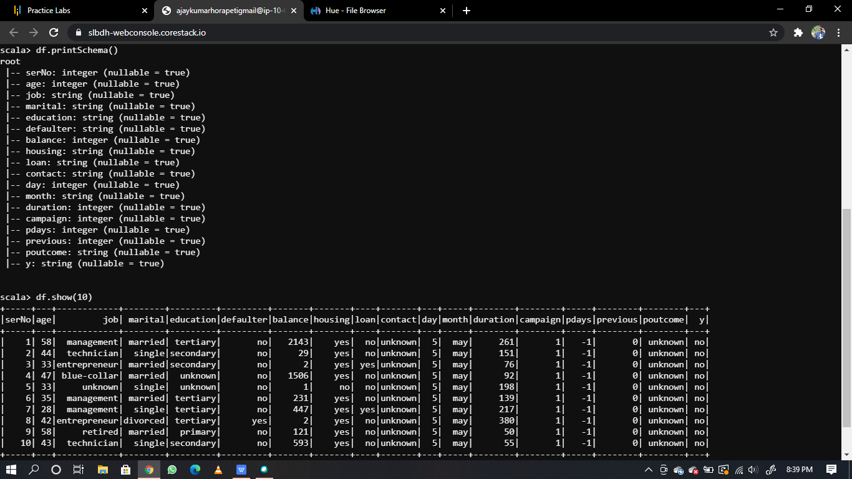

1. *Give marketing success rate (No. of people subscribed / total no. of entries)*

*- Give marketing failure rate*

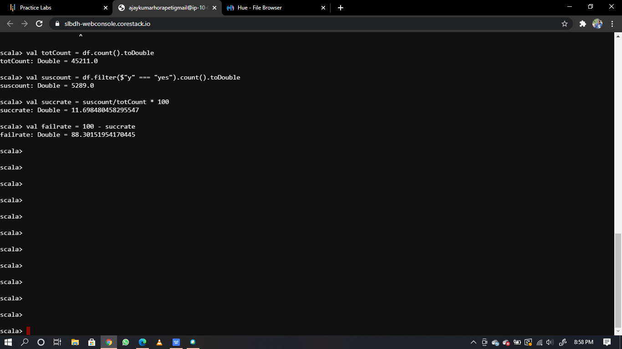

1. *Give the maximum, mean, and minimum age of the average targeted customer*

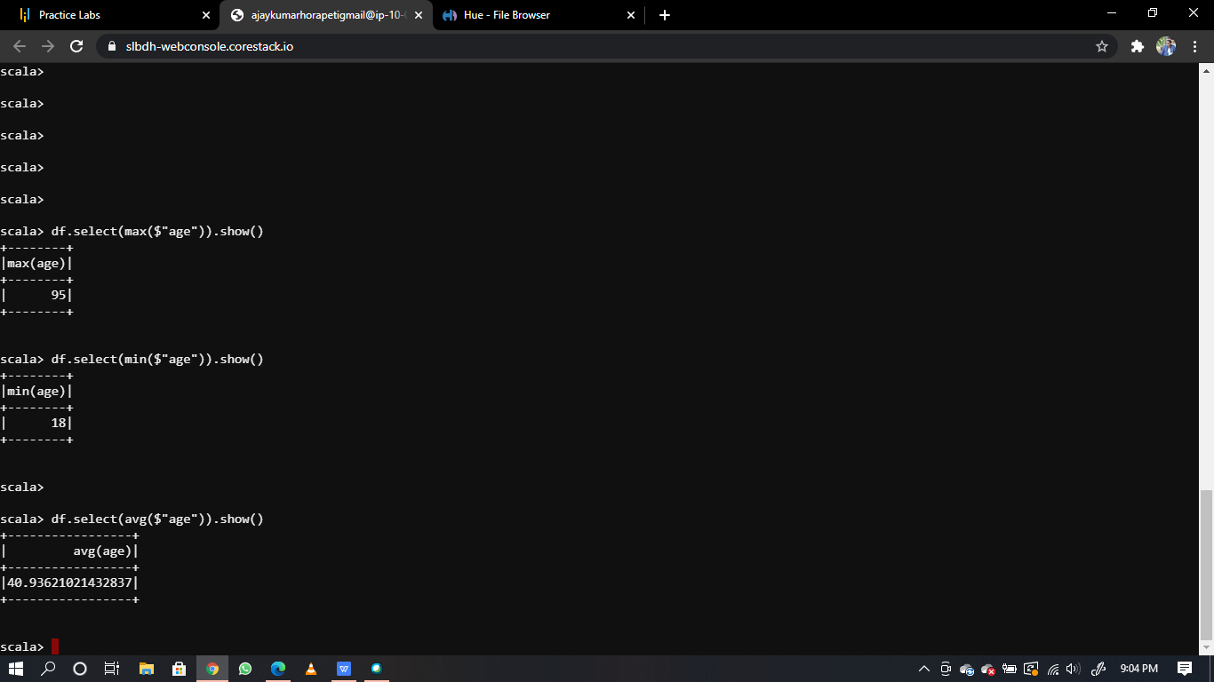

1. *Check the quality of customers by checking average balance, median balance of customers*

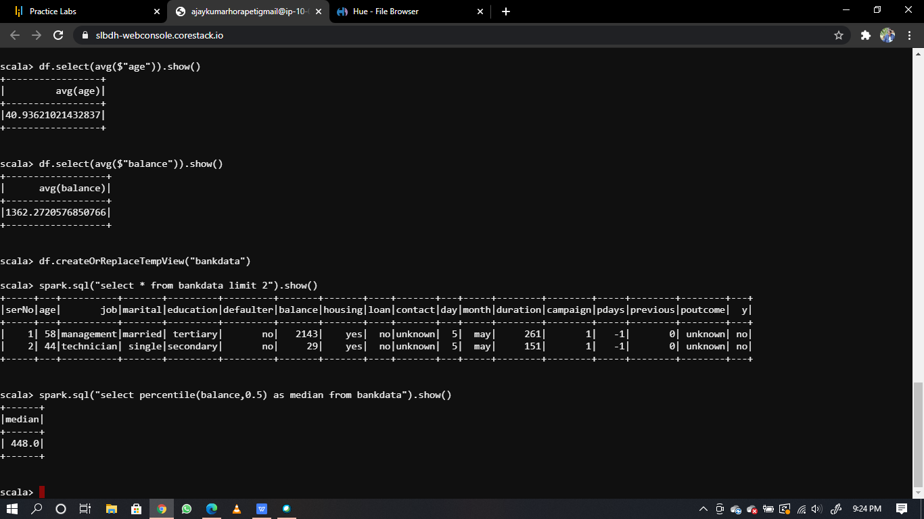

1. *Check if age matters in marketing subscription for deposit*

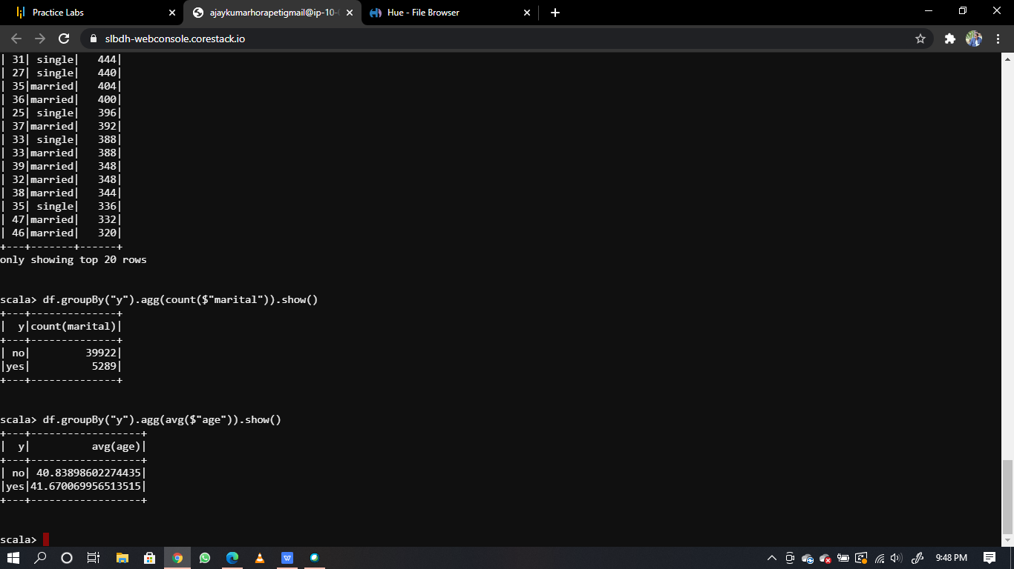

1. *Check if marital status mattered for a subscription to deposit*



1. *Check if age and marital status together mattered for a subscription to deposit scheme*

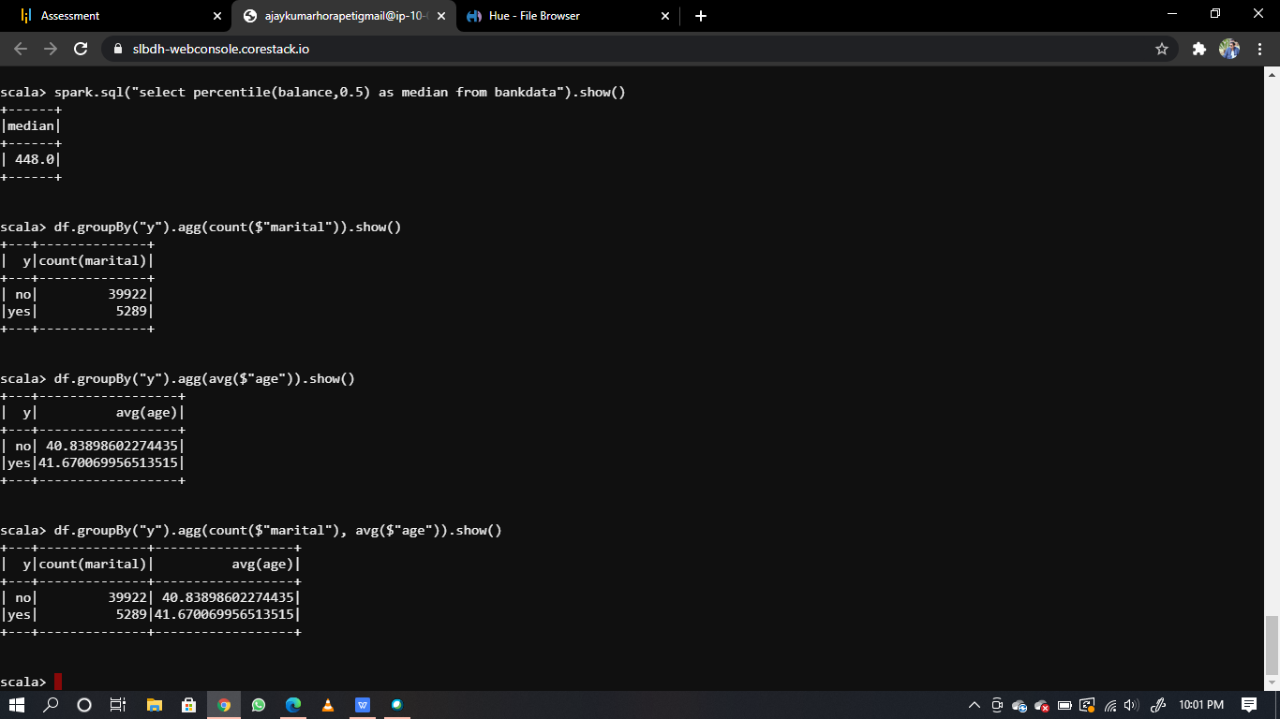

1. *Do feature engineering for the bank and find the right age effect on the campaign.*

